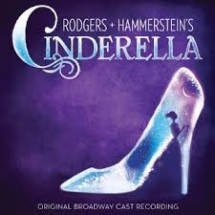  February 2017 |  | Remind App  Parents please text @bippity to 81010 to stay up to date with reminders .  Costume Fee  To help cover the costs of costumes/props we are asking for a $10 donation per child to the DCS Foundation due by February 1st. This will give you three line ads for the program  Tentative Performance Date  Our tentative performance date will be May 25th at CSN Horn Theatre.  After School Rehearsals  Some characters will be called to rehearse after school students should be picked up promptly at 4:30. After school rehearsals will have a * next to it. Otherwise the names listed will be during seminar.  Parent Volunteers  If you are interested in helping with sets, costumes or hair/makeup please email me at brivera@dcslv.org

Monday | Tuesday | Wednesday | Thursday | Friday | Saturday | Sunday
 |  | 1 | 2 | 3 | 4 | 5
PRINCE/  CINDERELLA  AFTER SCHOOL |  | COSTUME FEE DUE
6 | 7 | 8 | 9 | 10 | 11 | 12
TOWNSPEOPLE  “Your Majesties”  King, Queen, Chef | “Your Majesties”  King, Queen, Chef | Cinderella, Step Family, Fairy Godmother | Leads
13 | 14 | 15 | 16 | 17 | 18 | 19
“Your Majesties”  King, Queen, Chef | Cinderella and Fairy Godmother | “Your Majesties”  King, Queen, Chef | All cast
20 | 21 | 22 | 23 | 24 | 25 | 26
Cinderella | King, Queen, Prince, Cinderella, Step family, Herald | Cinderella, Step Family, Fairy Godmother | All cast | Friday School All cast Rehearsal TBA
27 | 28
Herald, Townspeople | Ensemble, Prince, Step sisters, Cinderella

